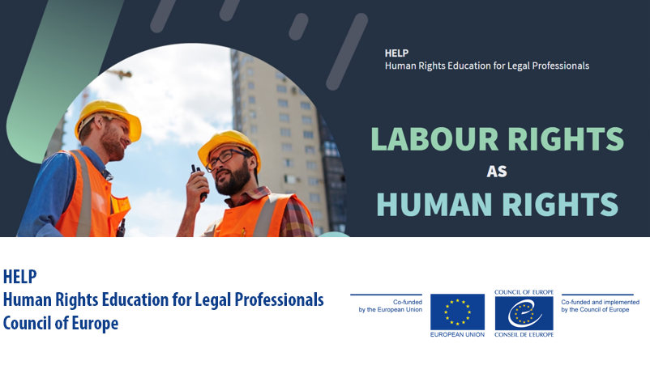
Labour Rights as Human Rights  HELP ONLINE COURSE | Duration: 13 hours  Available for free on the CoE HELP e-learning platform  Statement of Accomplishment  START COURSE

 | Council of Europe  Human Rights Education for Legal Professionals (HELP) Programme | 2021

Background & key concepts
In times of economic recession, the goal of full employment should go hand in hand with the protection of labour rights. Protecting labour rights benefits workers and their dependents and have a positive impact in their daily lives. It also benefits employers and society as it provides legal certainty in the workplace, protects the workforce and promotes sustainable growth. The benefits in terms of social cohesion and stability should not be underestimated either.
The European Social Charter (ESC) is a treaty of the Council of Europe (CoE) that guarantees fundamental social and economic rights as a counterpart to the European Convention on Human Rights (ECHR), which refers to civil and political rights. The ESC guarantees a broad range of everyday human rights related to employment, labour rights, housing, health, education, social protection and welfare. It provides extensive and complete protection of social rights and represents an essential component of the continent’s human rights architecture.
The ESC also serves as a point of reference in European Union law; most of the social rights in the Charter of Fundamental Rights of the EU (the CFREU or EU Charter) are based on the relevant articles of the ESC. The EU complements policy initiatives taken by its Member States by adopting directives that set minimum standards on topics such as (i) working and employment conditions, (ii) informing and consulting workers, or (iii) health and safety at work. There are over 240 million workers in the European Union alone. EU labour law goes indeed hand in hand with the single market, where fair competition has to be promoted without lowering labour standards.
A better understanding of the human rights’ dimension of labour rights by legal professionals is therefore needed.
The HELP course on “Labour Rights” covers in an interactive way the key concepts, the European system of protection of labour rights (stemming from the Council of Europe and the EU), the case law of the European Court of Human Rights (ECtHR) and the Court of Justice of the European Union (CJEU) as well as decisions of the European Committee of Social Rights (the ECSR). The latter is an independent body of a quasi-judicial nature that oversees the situation in the contracting states and develops case law.
This course deals both with individual and collective labour rights, primarily on the basis of the ESC and the relevant articles of the ECHR. The course also makes comparisons and synergies with the EU Charter and presents the relevant EU labour law. It also considers the key ILO conventions.

It is important to emphasize the indivisibility of all human rights, be they civil, political, economic, social or cultural, and that there can be no human rights society without full respect of social human rights, including labour rights.
The HELP online course on Labour Rights offers a detailed and comprehensive curriculum which covers the key concepts, the legal framework of the CoE and the EU (directly applicable at national level), the case law of the ECtHR, the CJEU and the ECSR as well as specific areas of labour law.
In all these European treaties, the point of departure is the full respect on the fundamental rights of employees, defined by the ILO in 1998:
- The prohibition of forced labour
- The prohibition of the worst forms of child labour
- The prohibition of discrimination in employment
- Right to associate peacefully (i.e. trade unions) and collective bargain
About the course
The course was initially developed under the “HELP in 28” Project. It was updated in 2021 under the EU-CoE “HELP in the EU II” project to contain the most recent developments. The update process was coordinated by the HELP Secretariat and involved several representatives of relevant CoE services: Secretariat of the European Social Charter, Secretariat of the Council of Europe Convention on Action against Trafficking in Human Beings, as well as from the Registry of the European Court of Human Rights.
Target audience
This free on-line course is primarily addressed to legal professionals (judges, prosecutors, private attorneys, lawyers and senior court staff) but can be also useful for national labour authorities (i.e. inspectorates) and other persons working in the field of labour rights.
How to access the HELP online course
The course is freely available in self-learning format on the CoE HELP e-learning platform. The overall length of the new edition of the online course is approximatively 13 hours and those who complete it in self-learning format can obtain an electronic ‘Statement of Accomplishment’.
To access the course, you need to have a HELP account. If you haven’t created one yet, you can sign up here, it only takes 2 minutes: http://help.elearning.ext.coe.int/login/signup.php.

Course outline
1 | Introduction  - The evolution of labour rights  - Labour rights under the European systems of protection  - Introduction to the European Social Charter
2 | Right to Work and Employment Relationship  - Right to work  - Right to just conditions of work  - Right to privacy at workplace
3 | Working time and Rest Periods  - Legal framework  - Working time and rest periods  - Rest periods  - Working time, rest periods and pay
4 | Fair Remuneration and Protection of Wages  - Decent standard of living  - Deductions from wages  - Safeguards in case of insolvency
5 | Termination of employment  - Procedural obligations to provide information  - Grounds of termination of employment  - Consequences of illegal dismissal
6 | Equality and Non-discrimination  - General aspects related to anti-discrimination  - Fighting discrimination in employment  - Protection of rights
7 | Collective Labour Rights  - Right to information and consultation  - Freedom of Association  - Negotiations and conclusion of collective agreements  - Labour disputes and collective action
8 | Occupational Safety and Health  - National Policy and regulatory framework  - Occupational accidents/diseases and procedural safeguards for victims  - Occupational health services
9  NEW! | Trafficking in Human Beings for the Purpose of Labour Exploitation  - Definition and related concepts  - Key actors  - Identification of victims  - Victims’ rights and assistance  - Investigation, prosecution and trials  - Corporate liability  - Access to remedies and compensation for victims

